**Oracle Forms Task (Mock-up Assessment)**

Create a simple Oracle Form to insert/update employee data.

The form must include validations (e.g., **salary not null**, **email format**) and a **button** to fetch department name from the database using PL/SQL.

EMP_ID (Primary key)

FIRST_NAME

LAST_NAME

EMAIL

SALARY

DEPARTMENT_ID

-------------------------------------------------------------------------------------------------------------

Attaching Objects Navigator from Form Builder-  
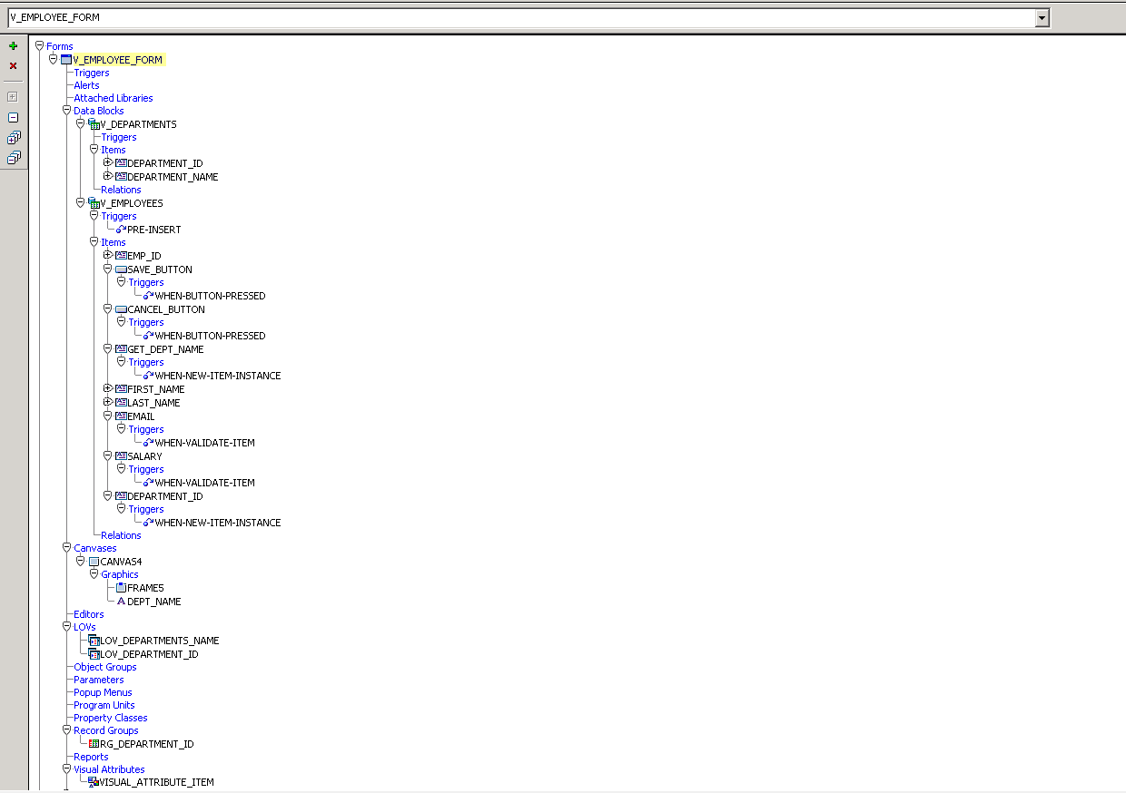

**Form Name**: `V_EMPLOYEE_FORM`

**Data Blocks:**

1. **V_DEPARTMENTS**

   - Fields: `DEPARTMENT_ID`, `DEPARTMENT_NAME`

   - Purpose: Department master data

2. **V_EMPLOYEES**

   - Fields: `EMP_ID`, `FIRST_NAME`, `LAST_NAME`, `EMAIL`, `SALARY`, `DEPARTMENT_ID`

   - Purpose: Employee data entry with department linkage

🔸 **Buttons**:

1. **SAVE_BUTTON** `WHEN-BUTTON-PRESSED` – Commits form data
2. **CANCEL_BUTTON**

WHEN-BUTTON-PRESSED` – Clears or rolls back form data

🔸 **Triggers Used:**

1. V_EMPLOYEES > PRE-INSERT.
2. GET_DEPT_NAME > WHEN-NEW-ITEM-INSTANCE.
3. EMAIL > WHEN-NEW-ITEM-INSTANCE.
4. SALARY > WHEN-NEW-ITEM-INSTANCE.
5. DEPARTMENT_ID > WHEN-NEW-ITEM-INSTANCE.
6. SAVE BUTTON > WHEN-BUTTON-PRESSED.
7. CANCEL BUTTON > WHEN-BUTTON-PRESSED.

🧾 **LOVs (List of Values):**

1. LOV_DEPARTMENT_ID` – For department selection by ID
2. LOV_DEPARTMENTS_NAME` – For department name selection by Name.

**🖼 Canvas: -** Contains all form items

- **Frames**:   
F_FRAMES, `A_DEPT_NAME` for layout grouping.

🧱 **Database Tables**

Based on the form, the following tables are used:

CREATE TABLE **V_DEPARTMENTS** (

DEPARTMENT_ID   NUMBER,

DEPARTMENT_NAME VARCHAR2(100)

);

CREATE TABLE **V_EMPLOYEES** (

EMP_ID         NUMBER,

FIRST_NAME     VARCHAR2(50),

LAST_NAME      VARCHAR2(50),

EMAIL          VARCHAR2(100),

SALARY         NUMBER,

DEPARTMENT_ID NUMBER

);

👨‍💻 Created By

**Vishal Bariya**

**Oracle Apps Technical Developer – Interview Assessment**